Start AEM CMD
> Java -Xmx1024m -jar aem-author-4502.jar -gui
Xmx1024 – Heap Size
Start AEM in DEBUG mode
> Java -XX:MaxHeapSize=2048m -Xdebug -Xrunjdwp:transport-dt_docket,server=y,suspend=n,address=45023 -jar aem-author-4502.jar -nofork
WEB Server AEM
Apache Jetty Server:
Eclipse Jetty provides a Web server and javax.servlet container, plus support for HTTP/2, WebSocket, OSGi, JMX, JNDI, JAAS and many other integrations. These components are open source and available for commercial use and distribution.
More info: https://www.eclipse.org/jetty/
Classic UI and Touch UI
- Classic UI: http://localhost:4502/libs/cq/core/content/welcome.html
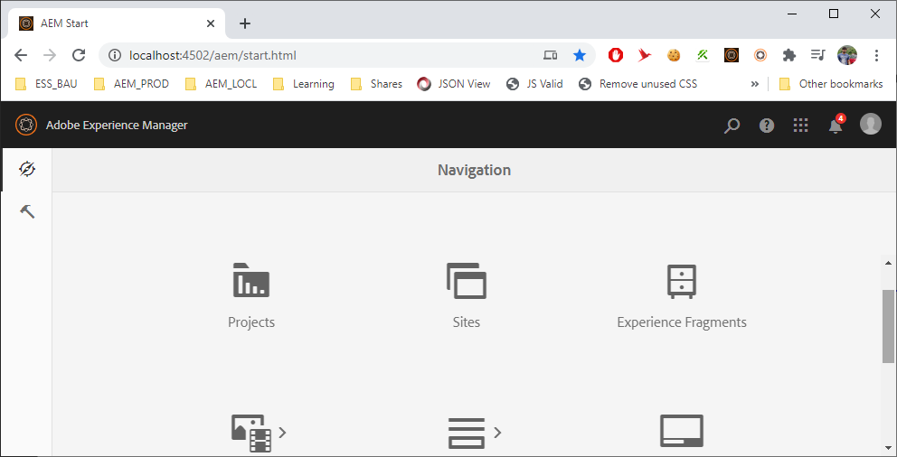
- Touch UI: http://localhost:4502/aem/start.html
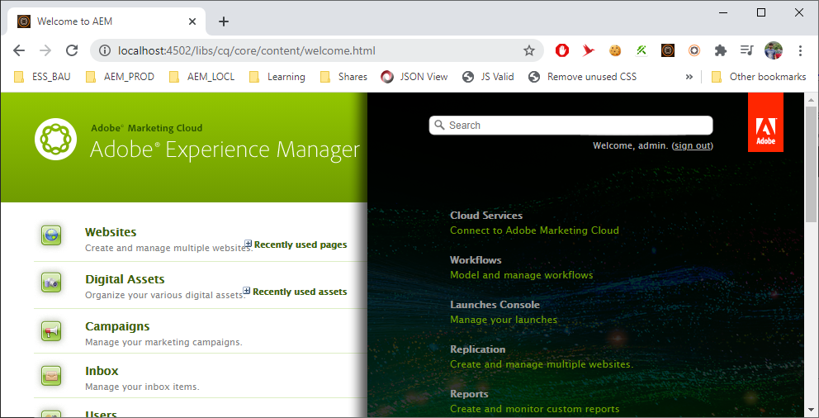
Author and publish Environment.
Data is stored in “C:\_IDEA\AEM\AUTHOR\crx-quickstart\repository\segmentstore”

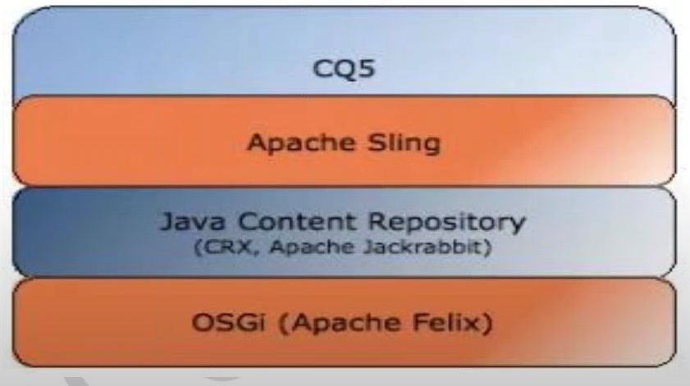
JCR (Content Repository API for Java):
It can be defined as the specifications for accessing content repository using JAVA API in uniform manner. So, JCR is "type of repository". CRX is an Adobe implementation of JCR. Similarly, Apache Jackrabbit is an external implementation of JCR by apache.
OSGi (Apache Felix):

OSGi

Page Creation:
- http://localhost:4502/aem/start.html
- Sites
- Select Project
- Select already created page
- Click on Create and then Page
- Select Template and click Next
- Add Title * and Name .
- Click on create and then Done
Folder Structure Of AEM Repository
/Apps: Custom Templates
/conf: All Configurations
/libs: out of box components
/content: all content of website
/etc: client lib, design dialog info
/tmp: temporary working area
/var: contains file that change & are updated bysystem
/home: info about users and group.
/oak:index jackrabbit Oak index definitions.

Project Structure Of AEM
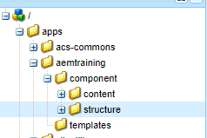
Following folders need to create:
- /apps/aemtraining/component
  - /apps/aemtraining/component/content
  - /apps/aemtraining/component/structure
- /apps/aemtraining/templates
Page rendering Component [Components] :
Header Component
Breadcrumb
Navigation Component

Text Component
Image Component

Footer Component

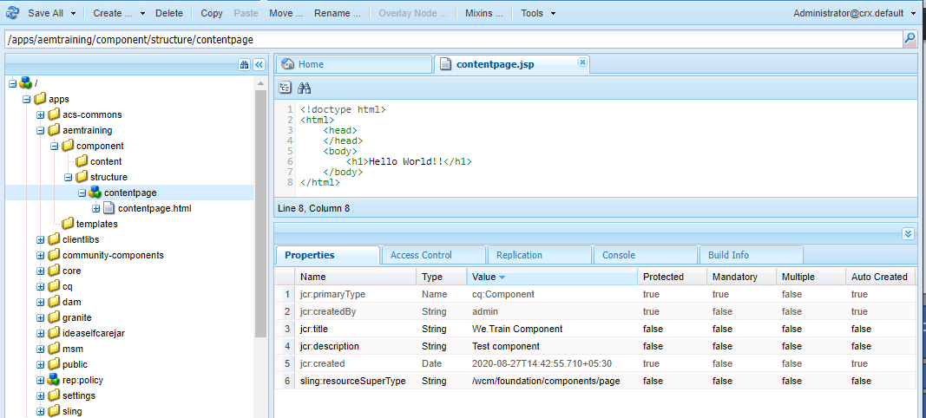

Steps:
- Right click on structure folder Create and click Create Component.
- Enter Label, Title, Description and Super Type - wcm/foundation/component/page
- Click Next and click Ok.
- Change cotentpage file extension to .html.
- Click on Save all.
Template Creation:
Blueprint of Page.
Steps:
- Right click on templates folder Create and click Create Template.
- Enter Label, Title, Description and Resource Type - aemtraining/component/content/contentpage change Ranking =1.
- Click next and allowed path /content(/.)?
- Click Next , Next and click Ok.
- Change cotentpage file extension to .html.
- Click on Save all.
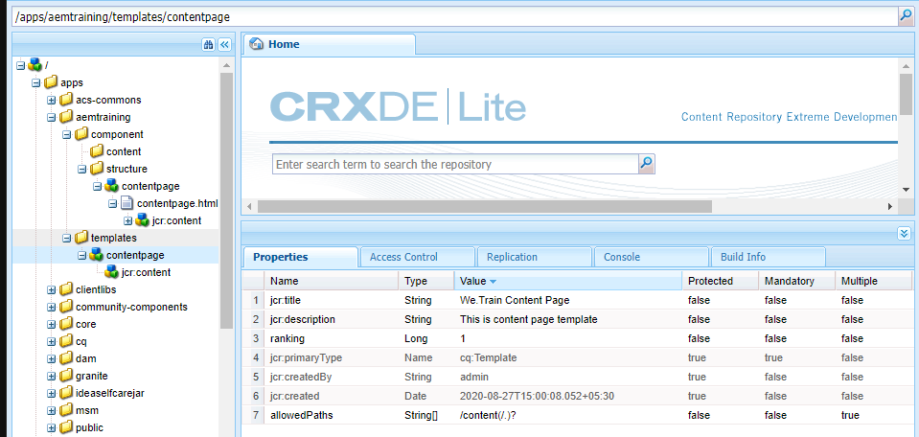
Fig: Content Page Properties
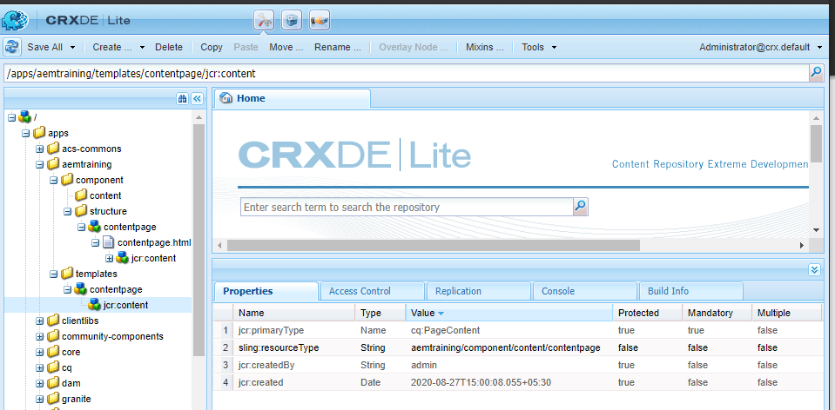
Fig: jcr:content Page Properties
Decomposing a URL in AEM

Apache Sling resource resolution

Apache sling selector manipulation

allowedPath and allowedTemplates (Template restriction)
allowedPath: Defines where the template can be used to create pages
Example:
allowedPath : /content(./*)?
To restrict we use /content/we-train(./*)?
allowedTemplates: Which template can be used within specified path.
Example:
Steps:
- Goto page path in crxDe “/content/we-train/jcr:content”
- Add prpperty cq:allowedTemplates: /apps/aemtraining/templates/.* templates (use string array).
- Then click on add and then Ok and Save.
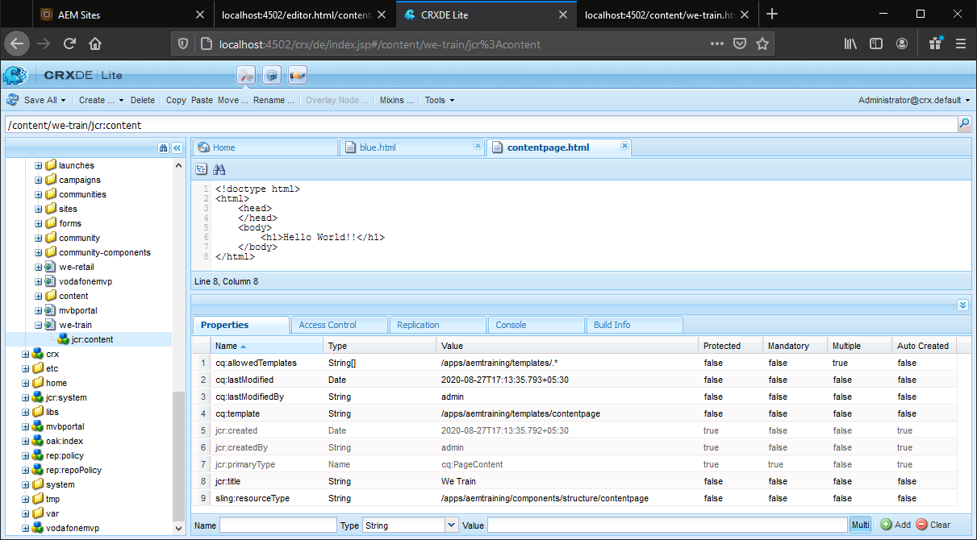
So at the time of page creation you can see only below templates.
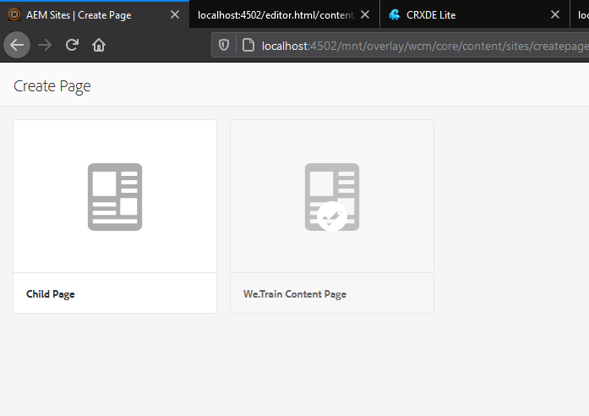
Adding Thumbnail to page
Steps:
- Go to sites
- Select page and click on properties.
- Click on thumbnail tab.
- Upload image and save and close.
Website Structure in AEM.
Pages creation
- Click on Sites Click on Create select page
- Select Template and click next.
- Add name and path of page.
- Click done.
Create pages structure like below
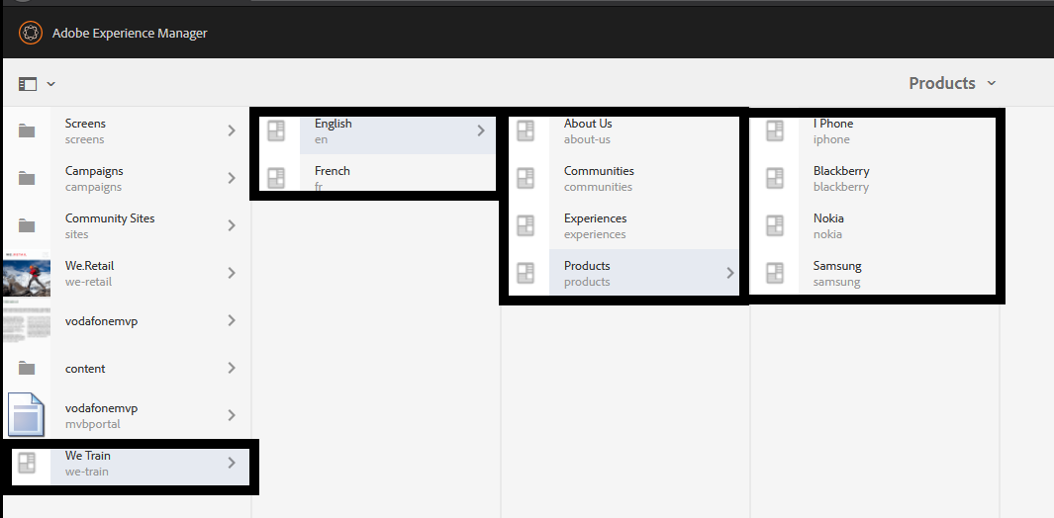
HTL (Html template language [Sightly] )
This is template language recommended by AEM.
HTL is HTML5
It is simplified development and security.
Separation and concern
Example:
<p data-sly-use.obj=”script-file.js”>
${obj.text}

HTL ( Sightly )
Expression
Sly Element
Attributes
Comments

Sightly Syntax and examples
Comments
HTML Comments <!-- Comment-->
Sightly Comments <--/* Comment */-->
Expressions
${} : Useful for extra expression
Example :
${properties.jcr:title}
${!currentPage.hasChild}
${varOne || varTwo}
${varOne == varTwo}

Sly Element
It removes from the output
This is useful for all the elements that are not the part of markup.
Example:
- <div data-sly-include=”header.html”> </div>
  - O/P: <div> header.html </div>

- <sly data-sly-include=”header.html”> </sly>
  - O/P: <div> header.html </div>
Sightly Attributes
data-sly-text: Replaces the content of HTML element with the specified text.
eg. <div data-sly-text=”${currentPage.title}”> Title Page</div>
data-sly-list: Repeats the children element
eg. <ul data-sly-list.child=”currentPage.listChildren” > <li>${child.title}</li> <ul>
data-sly-repeat: Repeats the same element.
eg.<ul> <li data-sly-repeat.child =”currentPage.listChildren”>${child.title}</li></ul>
data-sly-test: To hide or show an HTML element.
eg. <div data-sly-test=”${wcmmode.edit}”> this is edit mode </div>
data-sly-include: To include another file(html/jsp)
eg. <sly data-sly-include=”myfile.html”></sly>
data-sly-resource: To include component
eg. <sly data-sly-resource=${‘par’ @ resourceType=’foundation/components/parsys’}></sly>
data-sly-use: To invoke helper file
eg.<div data-sly-use.comp=”logic.js”> ${comp.myTitle}</div>
data-sly-call: Use to call/ invoke client library in component
eg. data-sly-call=”${clintlib.all @ categories=’cq.jquery’}”
currentPage Object, properties Object, currentNode Object
Using this objects we can rendering content for repositoty, access content of AEM ,same as querying database and display data.
currentPage Object: Intance of the page(AEM api) class.
Eg. ${currentPage.Title}
properties Object: Instance of the ValueMap(sling api) class. All properties of current resource.
Eg. ${properties.jcr:title}
currentNode Object: Instance of the node (JCR api) class.
Eg.${currentNode.Name}

Data-Sly-list
Array
List works with [String, Map, POJO]
Map
Data-sly-list:
Only inner block repeated.
<div data-sly-list.item={<classaname>.<MethodName> }>
<p> Book : <b>${item.<pojo element valur / Map Key>}</b></p>
</div>
Control your loop
<div data-sly-list.item={<classaname>.<MethodName> @begin = 2, end = 3}>
Display index or count
${ itemList.count} –> To get Item count.
Step : This is used for skip element from the list.
<div data-sly-list.item={<classaname>.<MethodName> @begin = 2, step2, end = 3}>
Sly First, Middle, Last
${ itemList.first}
${ itemList.middle}
${ itemList.last}
Data-sly-repeat
Same as list. The difference is only this will data-sly-repeat repeats the whole element that is marked. Complete block repeated.
Data-sly-template:
This template means which part you need to reuse this should be in .html only. You can multiple templates in single file also.
<div data-sly-template.authorBooks=”${@ books}”>
<div data-sly-list.item=”${books.bookDetailwithMap}”>
<p> Book: <b>${item.bookName}</p>
</div>
</div>

<div data-sly-template.mapAttributes=”${@ attribute}”>
<div data-sly-list.item=”${ attribute }”>
<p> Key: <b>${item }</p>
<p> Value: <b>${ attribute [item] }</p>
</div>
</div>

Data-sly-use and Data-sly-call: To use specific template.
<div data-sly-use.booksTemplate=”authorBooks.html”>
<sly data-sly-call=“${booksTemplate.authorBooks @books=htl}” />
<sly data-sly-call=“${booksTemplate.mapAttributes @ attribute=htl.booksMap}” />
</div>
Data-sly-attribute:
<sly data-sly-attribute.class />
<data-sly-attribute=”{htl.bookMap}”/>
Data-sly-include and Data-sly-resource
Include any file using this.
<sly data-sly-include=”include.html”>
<sly data-sly-include=”include.jsp” @propendPath=”/files”>
<sly data-sly-include=”@ path = include.html”>
<sly data-sly-include=”include.html” @appendPath=”/file”>
<sly data-sly-include=”include.html” @appendPath=”/file”,@propendPath=”/files”>

This use to include any resource i.e component, node, path.
<sly data-sly-resource=”${/content/aemgeek/us/en/author}”> -> Page included
<sly data-sly-resource=”${/content/aemgeek/us/en/author/jcr:content/parsys-8/author}”> ->Component included
<sly data-sly-resource=”${‘/content/aemgeek/us/en/author’ @appendPath=’/jcr:content/ parsys-8/author}'”> ->Component included
<sly data-sly-resource=”$’{/content/aemgeek/us/en/author/jcr:content/parsys-8/author’ @ addSelectors=’test’}> ->this will include file from component which name is test.
<sly data-sly-resource=”${/content/aemgeek/us/en/author/jcr:content/parsys-8/author” @resoueceType=”aemgeeks/components/content/author}”>
<sly data-sly-resource=”${/content/aemgeek/us/en/author/jcr:content/parsys-8/author” @resoueceType=”aemgeeks/components/content/author1}”> //This will not render
Time and Date in Sightly
<div> ${‘yyyy-MM-dd’ @ format=htl.publishDate, type=date}</div>
<div> ${‘yyyy-MM-dd HH:mm’ @ format=htl.publishDate, timezone=’UTC’}</div> ->Add Timezone
<div> ${‘yyyy-MM-dd HH:mm’ @ format=htl.publishDate, timezone=’GMT+05:30’}</div> ->Add Timezone

<div> ${‘yyyy-MM-dd HH:mm’ @ format=htl.publishDate, timezone=’UTC’ locale=’en’}</div> ->Add locale
Global Objects in Sightly/HTL
1)Properties: Information/Properties regarding components. Without using sling model. eg. ${properties.myproperty}
2)pageProperties: This object is providing page properties. Where your component is used. eg. ${pageProperties.jcr:title}
3)inheritedPageProperties: Inherited properties from page. Parent of that page properties that you can access. eg.${ inheritedPageProperties[‘jcr:title’]}
4) component: Information about the component. eg.${ component[‘title’]}
5) componentContext: It onpen for each component. It is independent to wcmmode. eg.${ componentContext.page.title}
6) resources: Object of current resource. Dragged Component treated as a current resource. eg.${ resource.path}
7) resourcePage: On the pages where w dreg n drop component provide info that page. eg.${resourcePage.path}
8)currentDesign: If any node is not applied the default node. eg.${currentDesign.path}
9)currentNode: eg.${currentNode.path}
10)currentPage: eg.${currentPage.path}
11) resourceDesign: Same as currentDesign. eg.${resourceDesign.path}
12)wcmmode: It provide info about which mode you are. eg.${wcmmode.edit} / ${wcmmode.preview}

Context/HTL Context:
- styleToken: If only have string without space, then you need to use this. ex:. <div style=”colour: ${‘#FFA500’ @ context=’styleToken’}”></div>
- styleString: If only have string with space, then you need to use this. ex:. <div style=”font-family: ${‘arial, sans-seif’ @ context=’styleString’}”></div>
- scriptToken: <input type=”button” onclick=”{‘testScriptContext’ @ context=’scriptToken’}()”>
- html: <div ${‘<h1>Vinayak</h1>’ @ context=’html’}></div>
- uri:
- numbers: ${‘12348827’ @ context=’numbers’}
- unsafe: Should not use. This is not recommended.

Number Formatting:
- ${‘#.00’ @ format=’1234.67’, type=’number’} Output 1234.67
- ${‘#,##.00’ @ format=’100’, type=’number’} Output 1,234.67
- ${‘#.00;(#.00)’ @ format=’100’, type=’number’} Output 1234.67
- ${‘#.###;-#.###’ @ format=’100’, type=’number’} Output 1234.67
- ${‘#.00E00’ @ format=’100’, type=’number’} Output 1235E04
- ${‘#%’ @ format=’100’, type=’number’} Output 123467%

data-sly-set:
Use existing object into the page instead of calling every time.
Join, In and Format in Sightly:
JOIN: Provide provision for print complete list in single line without loop.
${htl.bookList @ join=’ ,’} Op is CSS, Java, AEM
IN: To search any item in the String, Array, List, Map[Key is present or not].
    - ${ ‘a‘ ‘in’ ‘abc’} OP True
    - ${‘JAVA’ in htl.booksArray} OP is True
    - ${‘attribute’ in htl.booksMap} OP is False
FORMAT: How to format string.
${‘Book {0} out of total Books {1}’@format=[item, htl.bookList.size]}

URL Manipulation:
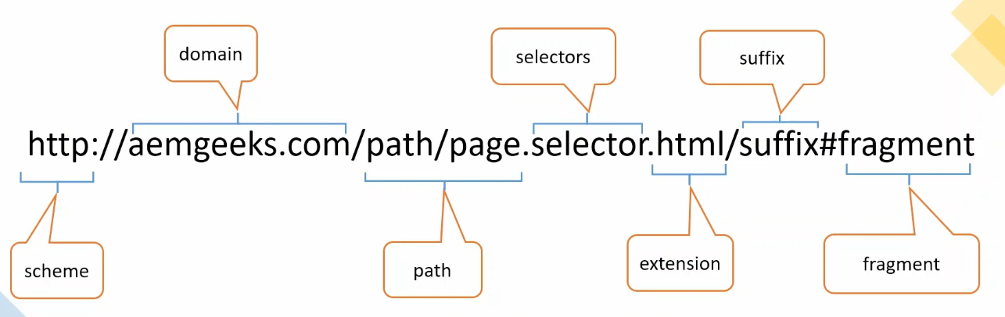

Scheme
<div>${‘//aemgeks.com/path/page.html @ scheme=’http’}</div>
Domain
<div>${‘///path/page.html @ domain=’aemgeeks.com’}</div>
Selectors
1) addSelectors
2) removeSelectors
Extension
Suffix
1) prependSuffix
2) appendSuffix
fragment

sly tag and sightly comments:
Used to remove unnecessary element from code. If you write using <sly></sly> the sly will not print.
Eg <sly data-sly-use.htl=com.aem.mytest” data-sly-unwrap=”${false}”></sly>

There is two types of comment in sightly
1)Html Comment: <!-- Your text/Code here -->
2)Sightly Comment; <!--/* Your text/Code here */-->

Render basic page content in AEM
How to render basic page content using properties, currentPage, currentNode etc.
Steps:
- Go to crx de.
- And navigate to /apps/aemtraining/components/structure/contentpage .
- This is our content.
- Go to contentpage.html
- And replace code from git and paste in contentpage.html. Git Link
- Then Open the “English” page form sites. (Click on page and click on edit).
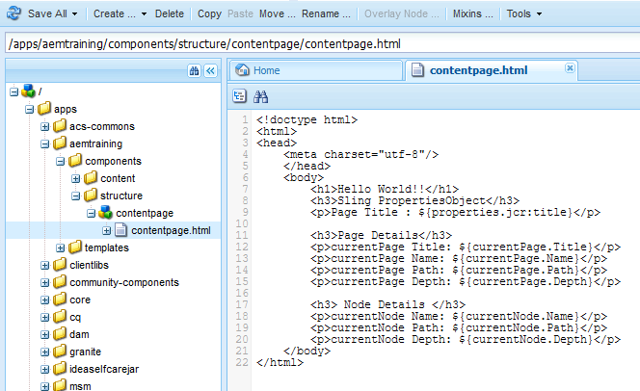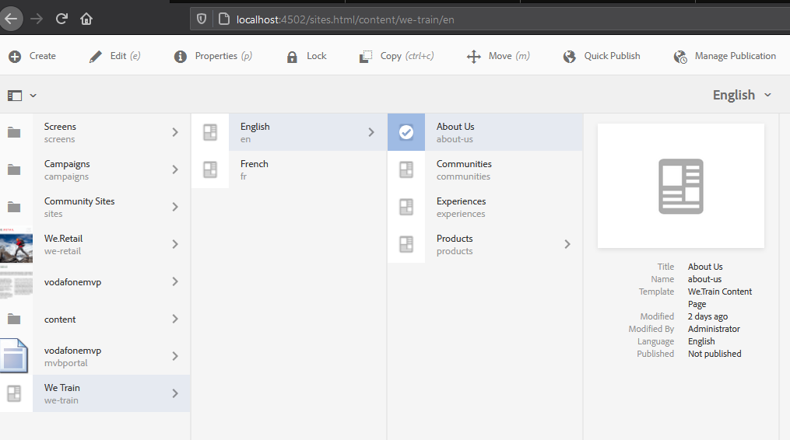

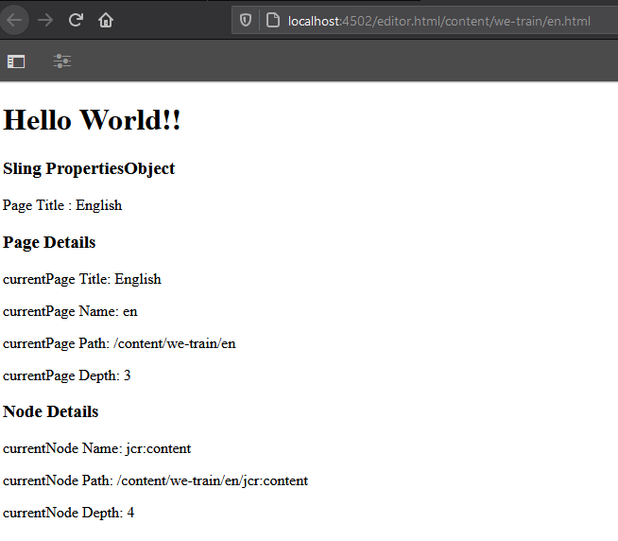

Modularize the Page rendering(contentpage) component
Enables of coma structure and reduce code redundancy.
- Navigate to /apps/aemtraining/components/structure/contentpage using crx console.
- Right click and create file like header.html, footer.html, contentpage.html, body.html.
- And copy and paste from GIT. Git Link

Inheritance in AEM:
Same as Java. Using Parents properties by child.
Client Library
To keep and manage client-side resources (js, CSS, images etc.). the use of this is to keep all the client-side resources organized in project folders in the CRX repository.
How to call:
JS: <sly data-sly-use.clientLib=”/libs/granit/sightly/templates/clientlib.html” data-sly-call=”$clientLib.js @ categories=’we.train.all’}”/>
CSS: <sly data-sly-use.clientLib=”/libs/granit/sightly/templates/clientlib.html” data-sly-call=”$clientLib.css @ categories=’we.train.all’}”/>
ALL: <sly data-sly-use.clientLib=”/libs/granit/sightly/templates/clientlib.html” data-sly-call=”$clientLib.all @ categories=’we.train.all’}”/>
Categories: To identify the respective client library.
Dependency: This is a list of other client library categories on which this library filder depends
Eg. Script depends on jquery
Embed: Used to embed code from other libraries. EX: CL1 Extends CL2= CL1+CL2

Designs are stored in /etc/designs/ folder
To open AEM Tools -> http://localhost:4502/miscadmin
Steps:
- Tools -> Operations->Configuration
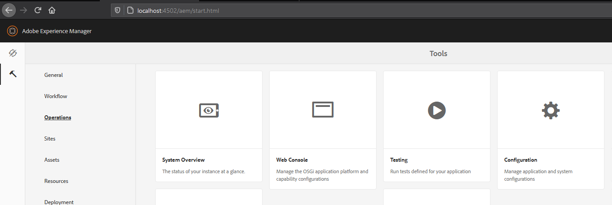

DISPATCHER
https://archive.apache.org/dist/httpd/binaries/win32/

OAK Seach and Solr
https://blog.3sharecorp.com/aem-search-vs.-solr-search
AEM Search VS. Solr Search
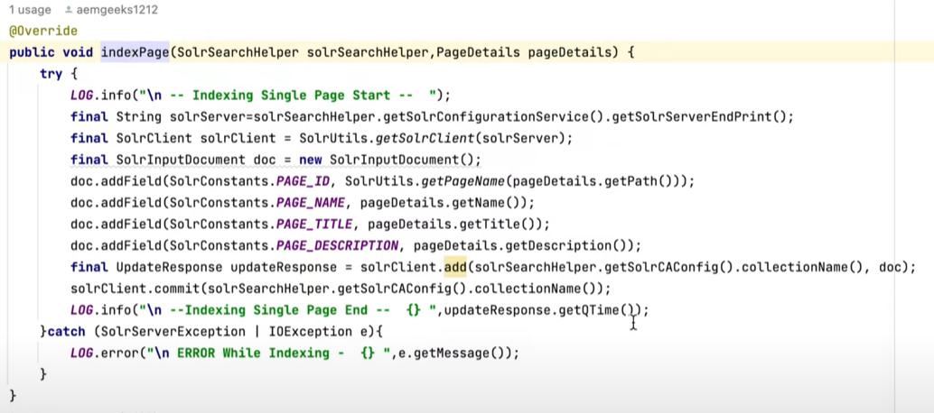
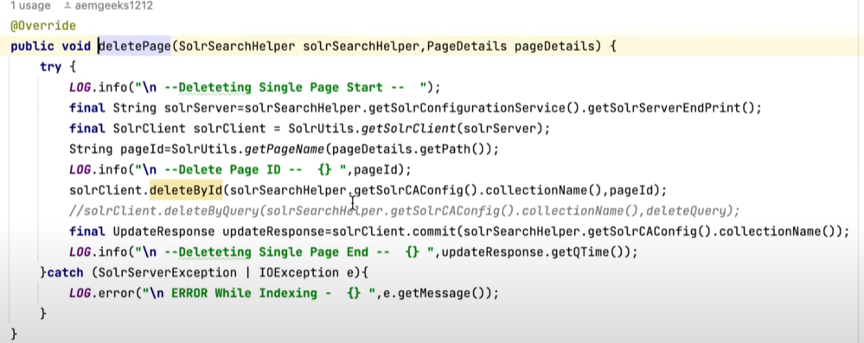
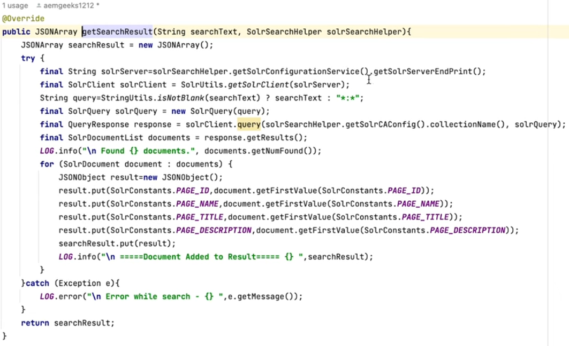

How URL Resoluation is working in AEM
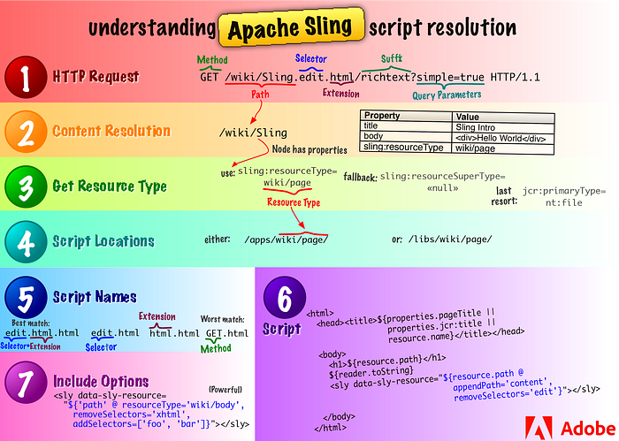
AEM Upgrade/ Migration
Upgrading to Adobe Experience Manager 6.5 | Adobe Experience Manager
